

**The Ultimate Streaming App**

|  |  |
| --- | --- |
| **Unit Title:** | 6G6Z1114: User Experience and Interaction Design |
| **Assignment ID:** | 1CWK100 |
| **Student Name:** | Nathan Butler |
| **Student Number:** | 19081449 |

Contents

Contents 1

Component One 2

Introduction 2

Identifying competitor apps 3

Identifying user groups 5

Developing personas 6

User Persona - Student 6

User Persona – Commuter 7

User Persona – Work from Home 8

Documenting scenarios 9

Generating functional requirements 9

Generating non-functional requirements 10

Drawing navigation diagrams 11

Paper prototyping 12

First prototype 12

Second Prototype 19

Conducting heuristic evaluations 28

Final Designs 31

Shortlisting and Analysing competitor apps 42

Spotify 42

Amazon Music 42

Deezer 43

YT Music 43

Tidal 43

Graph of SUS scores 44

Analysing competitor apps 44

Heuristic evaluation Spotify 45

Heuristic evaluation Amazon 47

Component Two 50

Tasks 50

Plan for deployment 51

Component Three 52

Future development plan 52

Sonic Interaction 52

Affective design 53

Bibliography 54

# Component One

## Introduction

Music streaming apps of today are not listening to their consumers concerns. The Ultimate Music Streaming app plans to take all of the concerns and complaints users have made toward various different music apps in order to create the superior streaming app void of all of the features that are regularly criticised. As this is a market with several other popular apps, it is long overdue that a streaming platform is constructed that listens to its consumers whilst offering premium and usually paid for features with no charges, to make a high-quality service accessible to all.

To begin with, I went through several stages of research and design which included identifying competitor apps and the user groups. Then I created my own user personas, which now included a work from home user group, borne of the pandemic. Using this information I created several scenarios of different issues that the user groups might have faced and then created a list of functional and non-functional requirements. From here I could create a navigation diagram along with the initial prototypes. Doing heuristic analysis and subsequent evaluations of other apps, I could amend any issues of the initial prototypes to create my final designs.

I led this entire project from the research stage to designing the new app look. I extracted the frustrations of the personas and scenarios in order to create an app prototype that the consumers would best be benefitted by.

## Identifying competitor apps

|  |  |  |  |  |  |
| --- | --- | --- | --- | --- | --- |
| ***Music Streaming Apps*** | | | | | |
| **Name** | **Vision / Identity** | **Distinguishing Features** | **Interaction** | **Visual Design** | **Diversity / Inclusivity** |
| *Spotify* | * Playlists made for you * Discover new music * Podcasts | * Create Playlists * Listen across different devices * Play Local files * Share music you find * Free and Paid memberships * Podcasts * Listen offline * Car Mode * Personalisation, gets you to add artists the user is interested in so the service can recommend music | * Voice Control * Keyboard * Touchscreen | * Clean * Dark Colours | * Larger Text * Transcripts for Podcasts |
| *Amazon Music* | * Ad Free * High Quality Audio * Podcasts * Unlimited Skips * Listen Offline * Hands free listening | * Create Playlists * Listen across different devices * Play Local files * Share music you find * Free and Paid memberships * Podcasts * Listen offline * Car Mode * Personalisation, gets you to add artists the user is interested in so the service can recommend music | * Voice Control * Keyboard * Touchscreen | * Clean * Dark Colours |  |
| *Deezer* | * Personal recommendations * Offline listening * Playlists * Included Lyrics * Podcasts * Identify songs | * Free and Paid memberships * SongCatcher, being able to identify songs that are being played out load that the user may not know * Exclude music * Play songs based on the user’s mood * Play songs with lyrics * Personalisation, gets you to add artists the user is interested in so the service can recommend music | * Voice Control * Keyboard * Touchscreen | * Bright * Colourful | * Light or Dark Mode |
| *YouTube Music* | * Personalised recommendations * Live performances and covers * Trending music * Listen offline * Ad free | * Create Playlists * Listen across different devices * Play Local files * Share music you find * Free and Paid memberships * Listen offline * Car Mode * Personalisation, gets you to add artists the user is interested in so the service can recommend music | * Uses Google assistant voice control | * Clean * Dark Colours | * Captions |
| *Tidal* | * Great sound quality * Ad Free * Listen Offline * Personalised recommendations * Playlists * Videos * Live Shows | * Create Playlists * Listen across different devices * Share music you find * Free and Paid memberships * Listen offline * Personalisation, gets you to add artists the user is interested in so the service can recommend music * Videos | * Voice Control * Keyboard * Touchscreen | * Clean * Dark Colours |  |

## Identifying user groups

To identify the user groups, I found and read a variety of user reviews and discussions about music streaming apps, I discovered that the type of people who used these apps were students, commuters and people who worked from home. To get information on the user groups, 3- and 4-star reviews were the most useful as it was users who mostly had positive experiences with the streaming apps and had constructive complaints as to why it wasn’t a full 5-star review.

Research:

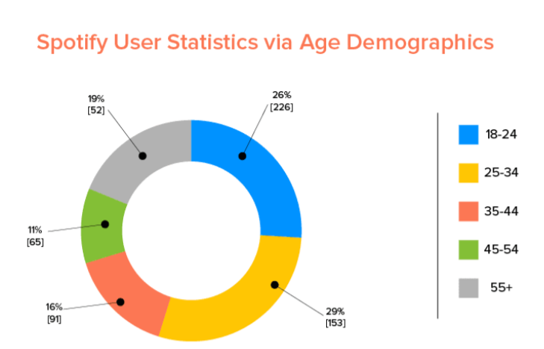G1. Source: (Hlebowitsh, 2021)

* 29% of Spotify users are millennials, while 26% of them are under 24 years old.
* Spotify is also popular with seniors, with 19% of the user base over the age of 55+.
* In terms of gender, 56% of Spotify users are male and 44% are female.

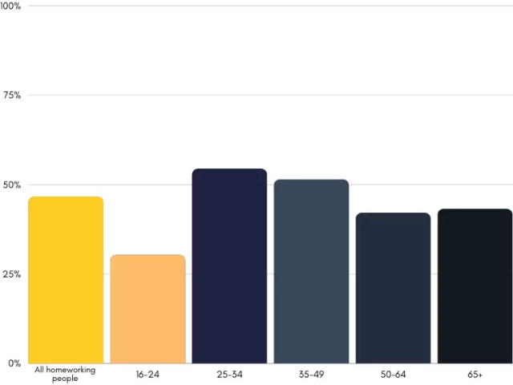G2. Source (Ćalić, 2021)

Based on the graphs above (G1, G2), I have developed three personas. The first one is a student, based on the fact that 26% of users are under 24. The next user is a senior who commutes to work as seniors take up 19% of the user base. My final persona is a millennial who works from home, due to the fact that 29% of users are millennials and the covid 19 pandemic drastically increased the amount of people who now work from home, making just over 50% of all homeworking people in the UK alone.

## Developing personas

### User Persona - Student

**Name**: Roman McCormack

**Five key characteristics about this person:**

* Loves listening to the latest music whilst revising
* Love listening to a podcast while going out on nature walks
* Extrovert
* Outdoorsy
* Environmentally conscious
* Self-Disciplined

**Background Story:** Roman is 20 in his last year of university studying history and looking to pursue a master’s degree. He is one of four children and is the eldest son. During term time he goes to several different pubs and clubs with his friends and frequents his local when at home. He is also an avid gamer. Roman is very environmentally conscious and so uses public transport a lot so spends a lot of time on streaming services during journeys. He does a history degree and finds that podcasts are an important educational tool. He has 3 siblings and so shares a family plan for streaming services

**Motivations/Goals:**

* To keep on top of the latest music trends
* To share new music with his friends
* To keep playlists of his favourite music
* To keep on top of the latest historic podcasts

**What is this person looking for?**

Roman is looking for an inclusive and accessible app with the biggest library where he can listen to the latest music and podcasts. He would love a shazam type feature built into the app so he can find music he hears on the go.

**Frustrations**:

1. Place won’t save in a podcast in another streaming app
2. Wants offline mode to be easier as other apps constantly try to connect to the internet even when in offline mode thus hindering the offline experience
3. Would like more accessibility features in music streaming apps
4. Wants to be able to find music that he doesn’t know the name of using a shazam type in built feature

**What is this person most likely to say?**

“The FIFA soundtrack is banging this year

### User Persona – Commuter

**Name**: Janet Swaithwaite

**Five key characteristics about this person:**

* Outdoorsy
* Animal lover
* Motivated
* Driven
* Friendly

**Background Story:** Janet is a 55-year-oldOffice administrator, recently divorced with two children, a son aged 18 and a daughter aged 25. She got a new dog to help with her mental health and to combat loneliness after her divorce. She loves listening to 80’s music in the car on the way to work. Her children recently introduced her to podcasts, and she has been enjoying listening to true crime documentaries. She loves to take her dog on long daily walks. She is a part of a book and wine club consisting of local ladies in the area

**Motivations/Goals:**

* To climb the career ladder
* To find the latest true crime podcasts available to listen to online and offline

**What is this person looking for?**

Janet is looking for an app that is easy to navigate with large text as an option. She would like a large library of podcasts and 80’s music at her disposal

**Frustrations**:

1. Buffering when online
2. As she is older, she isn’t tech savvy, she requires a simplistic user interface
3. Would like to be able to find lyrics to the songs

**What is this person most likely to say?**

“It’s wine o’clock!”

### A person with long hair Description automatically generated with low confidenceUser Persona – Work from Home

**Name**: Mark Howard

**Five key characteristics about this person:**

* Introverted
* Wears contact lenses
* Career-oriented
* Tech obsessed
* Bookworm

**Background Story:** Mark is a30-year-old Web developer, he is married with no children. Every 3-4 years he changes roles to progress his career and learn new skills. He has two dogs. In his house he has a library with floor to ceiling bookshelves full of books

**Motivations/Goals:**

* Career Progression
* Life away from work to allow himself to wind down
* Music recommendations are aligned with taste and vibe

**What is this person looking for?** Mark is looking for a streaming app with curated playlists he can put on for background noise while he is working

**Frustrations**:

* Due to his seeing impairment, he would like options for different sized text.

**What is this person most likely to say?**

“When will George R R Martin release The Winds of Winter?”

## Documenting scenarios

|  |
| --- |
| **Scenario 1 – Roman McCormack** |
| Roman is 20 in his last year of university studying history and looking to pursue a master’s degree. Roman is in a clothes store and a song he really likes the sound of has come on the speaker. He would like to have his music streaming app automatically pick up the song to enable him to add to a playlist. In the ultimate music streaming app, Roman would go to the search area and press a button to listen for the song. The song comes back as coming from a band called The Maine, he goes ahead and listens to several of their top songs and added them all to his playlist. |

S1

|  |
| --- |
| **Scenario 2 - Janet Swaithwaite** |
| Janet is a 55-year-old Office administrator, recently divorced with two children. At Janet’s book and wine club, the group of ladies occasionally like to sing songs while listening to their playlist after a few wines. Janet uses her device to play the music. She has found that she often doesn’t know all the lyrics and would like an in-built feature so she can discreetly look at the lyrics while the ladies sing the songs. In the ultimate music streaming app, Janet would be able to simply tap a button on the play screen and the lyrics will show as they’re being sung. She now has less anxiety when it gets to that part of the night and sings the songs with confidence with the other ladies |

S2

|  |
| --- |
| **Scenario 3 - Mark Howard** |
| Mark is a 30-year-old Web developer, he is married with no children.  While loading up his regular music streaming app, he realised there was an update and the text for everything has reduced to a point where he now struggles to read the screen without squinting. He went to the settings and found a disappointing lack of accessibility settings and either had to download a third-party app to change the text size back to its original size or try to download the app on the previous update. On the ultimate music streaming app, Mark would simply head to the settings and change size to a medium size relative to his screen. He recognised that the settings option had a cog as its image and the text size option heading was already a larger size and knew where to head without any trouble. |

S3

## Generating functional requirements

Functional Requirements:

1. Registration/log in – The ability to log in so you can save music and have a music profile
2. Log out- the ability to log out once logged in
3. Browsing genres – browse music and podcast by genre
4. Music/podcast player – Must have a screen to show what’s playing with album art showing
5. Download/save songs for offline
6. Lyrics should show when the link is pressed on the play screen in real time. S2
7. Skip songs – To be able to skip a song for another
8. Loop/shuffle song – To be able to loop one song or shuffle the playlist
9. Search bar for a song/podcast
10. Create playlists- Create a playlist with different songs
11. Play playlist – Play music from a playlist
12. Music search function. To be able to search for a particular song S1
13. Accessibility settings – settings like dark mode or text size. S3

## Generating non-functional requirements

Non-functional requirements

* Encrypt login details – Research would need to be done to determine what is the best way to encrypt log in details
* Audio quality- What should the standard be? Can the user change the quality to use less internet or have it on the highest quality?
* Response time to play and pause.
* Download progress bar
* No internet screen. To have a screen to show when you have no internet available

## Drawing navigation diagrams

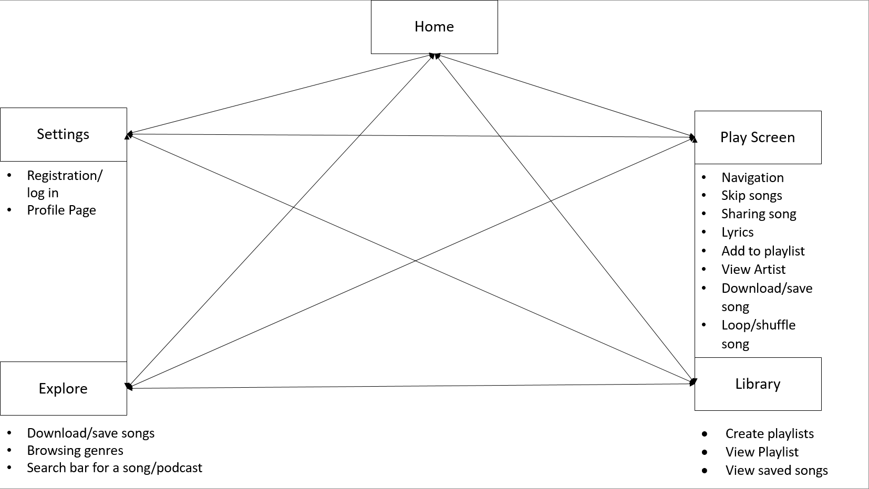

## Paper prototyping

### First prototype

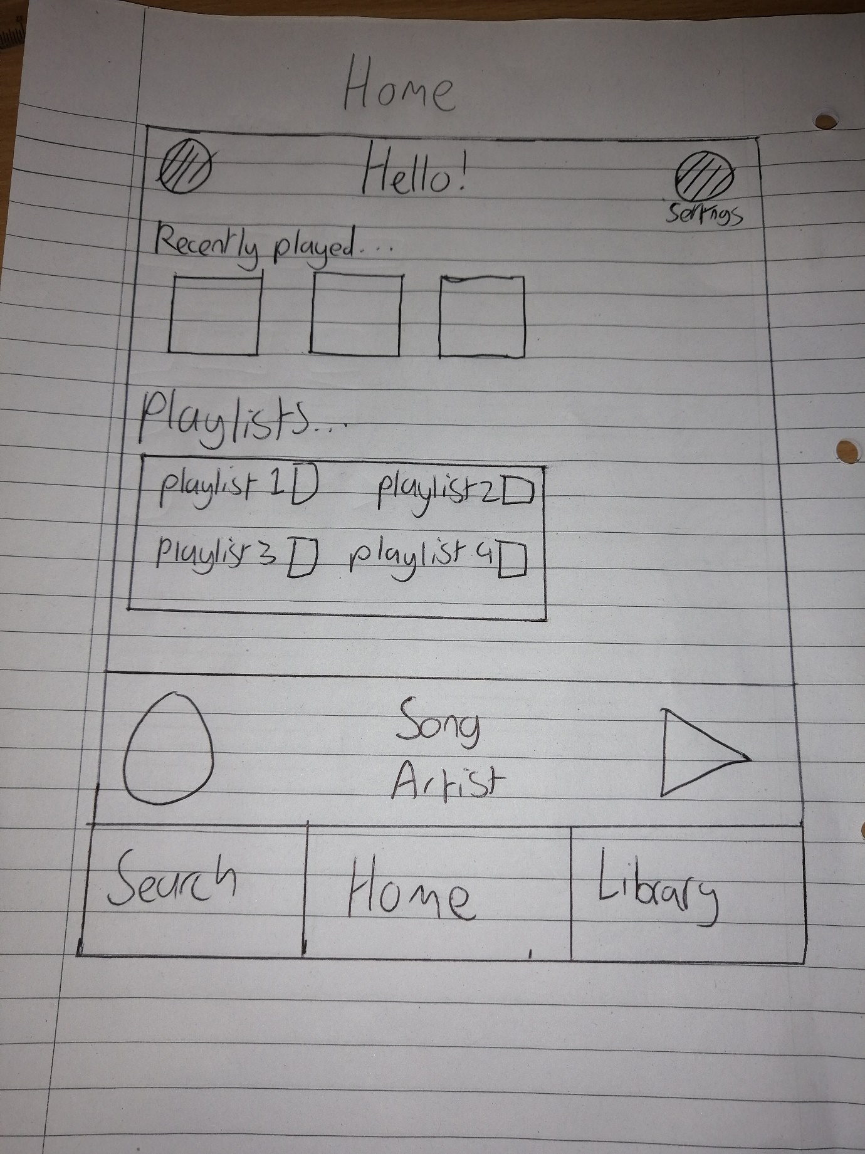

PR1.1

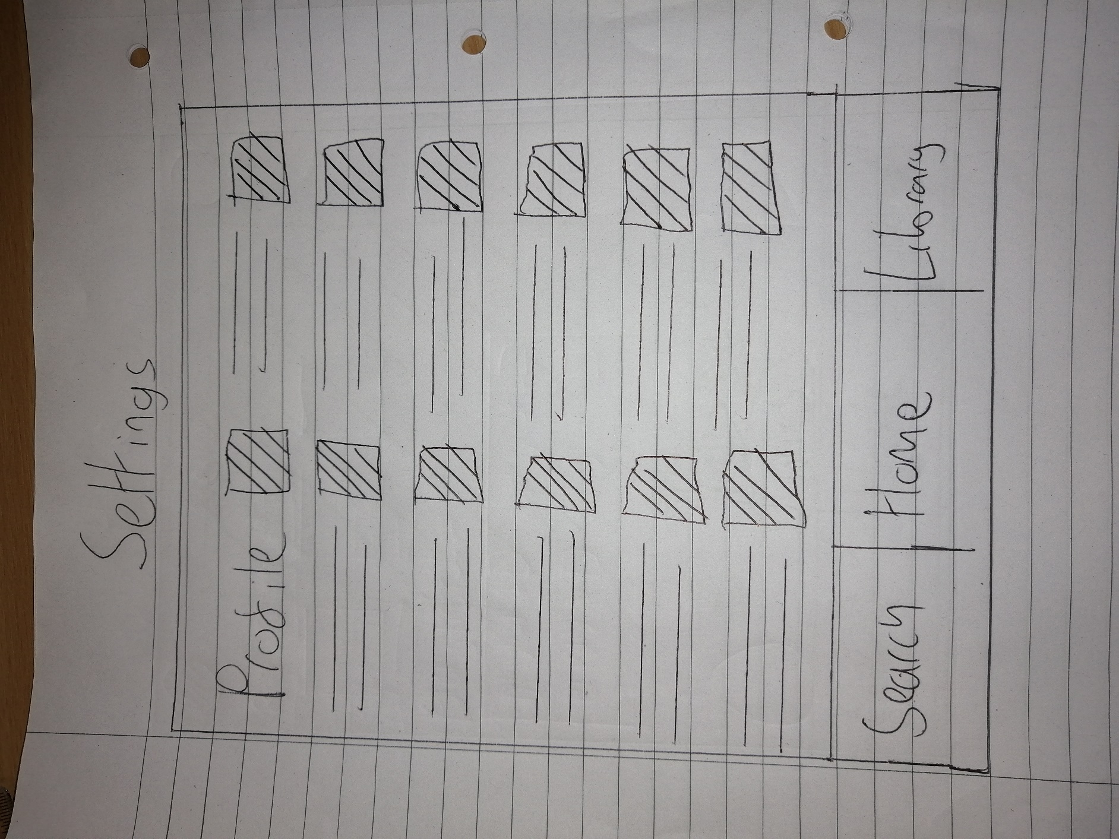

PR1.2

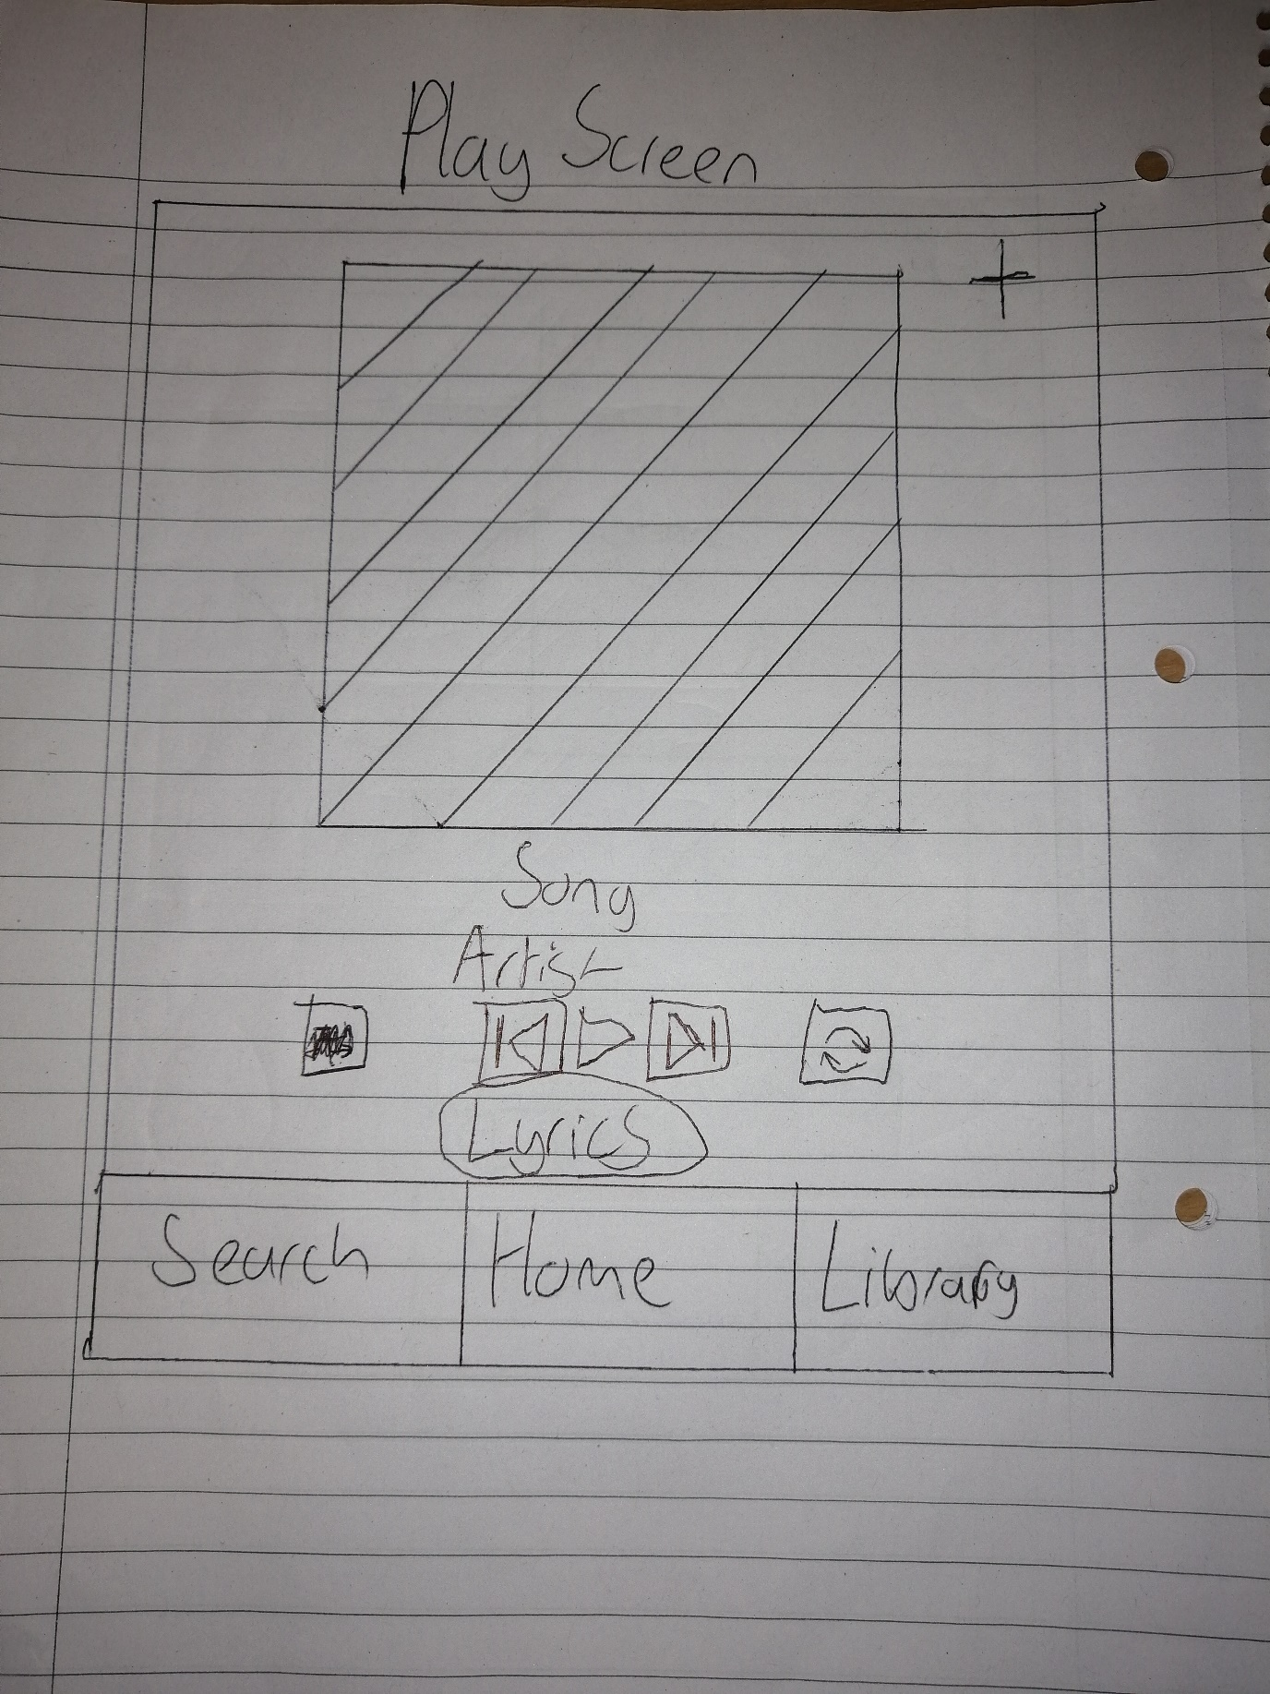

PR1.3

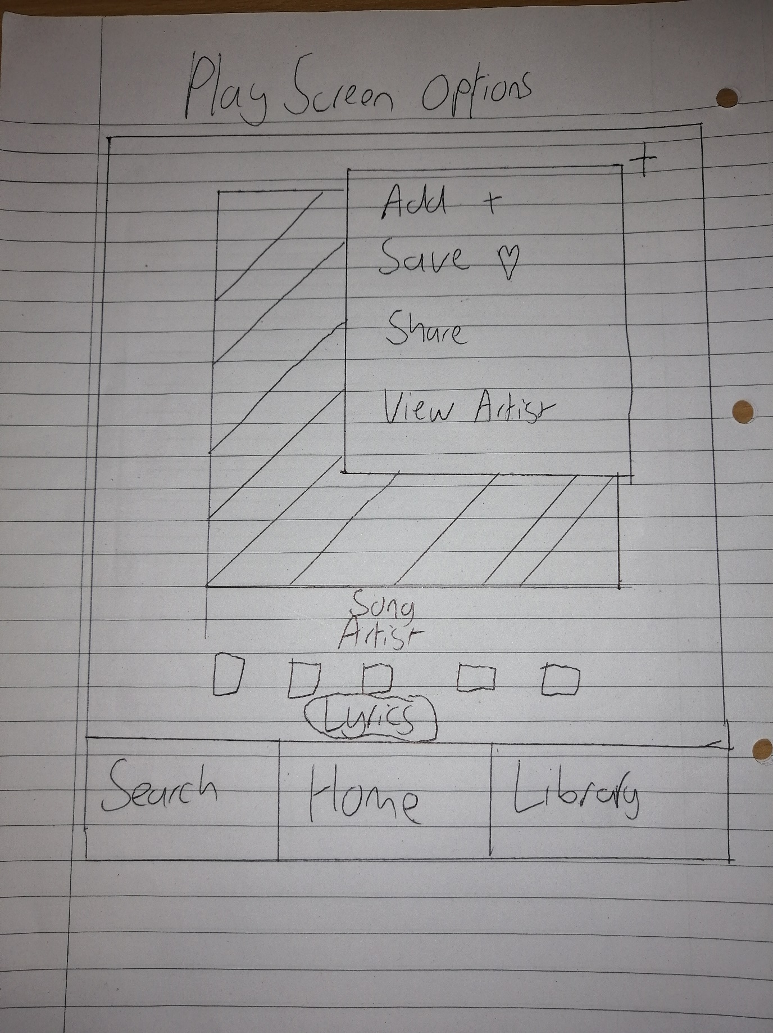

PR1.4

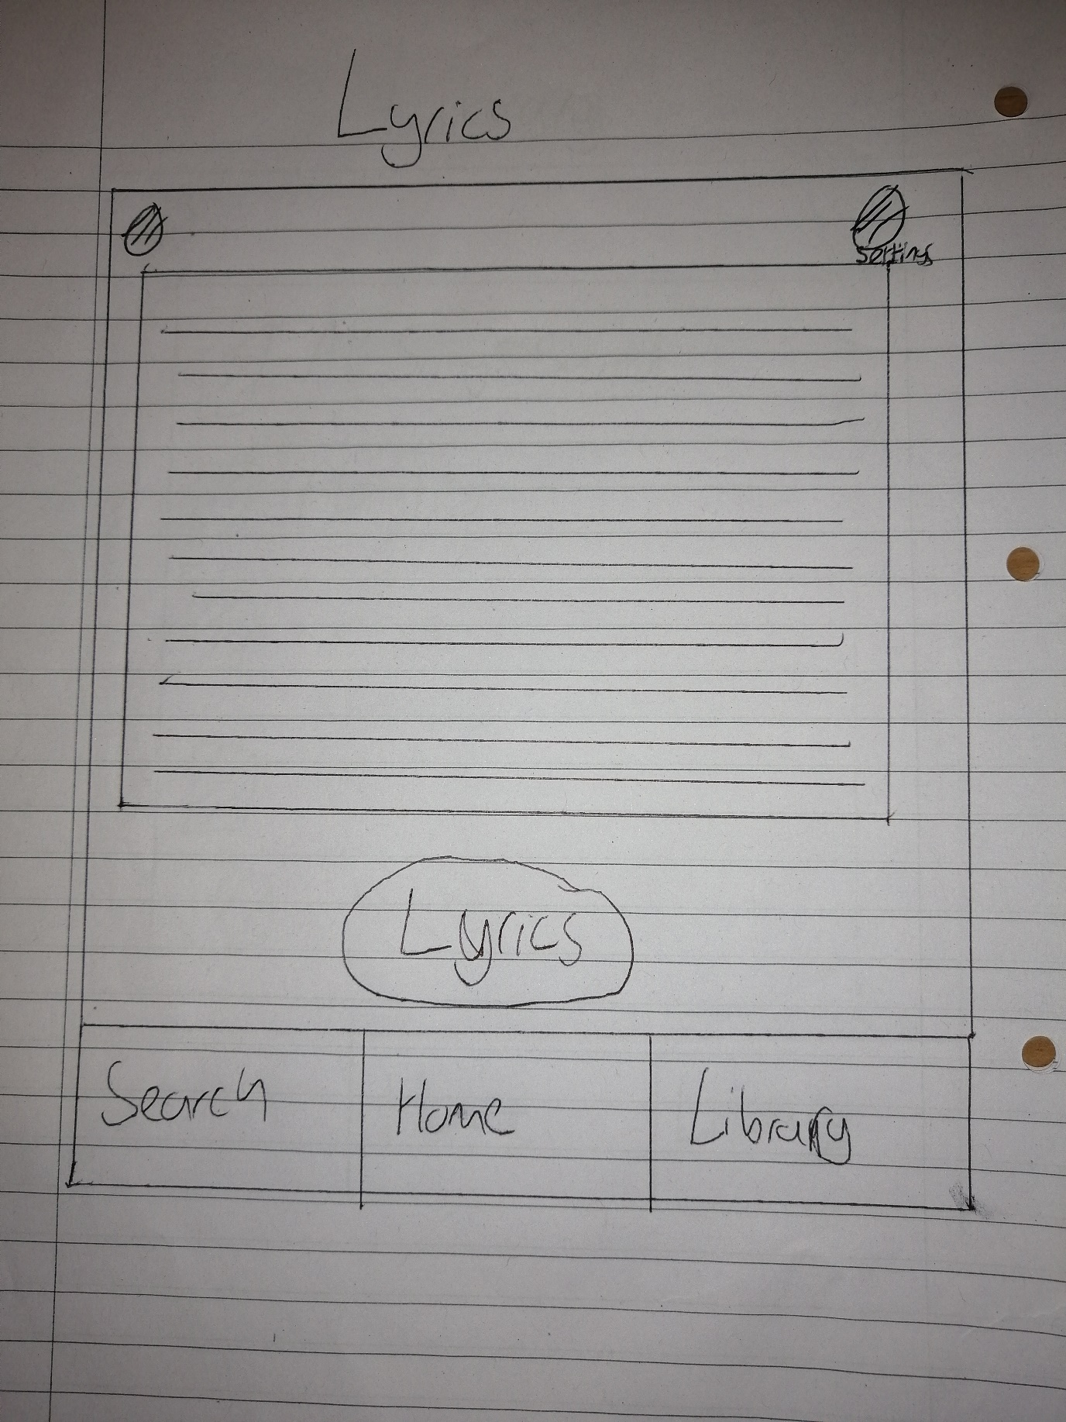

PR1.5

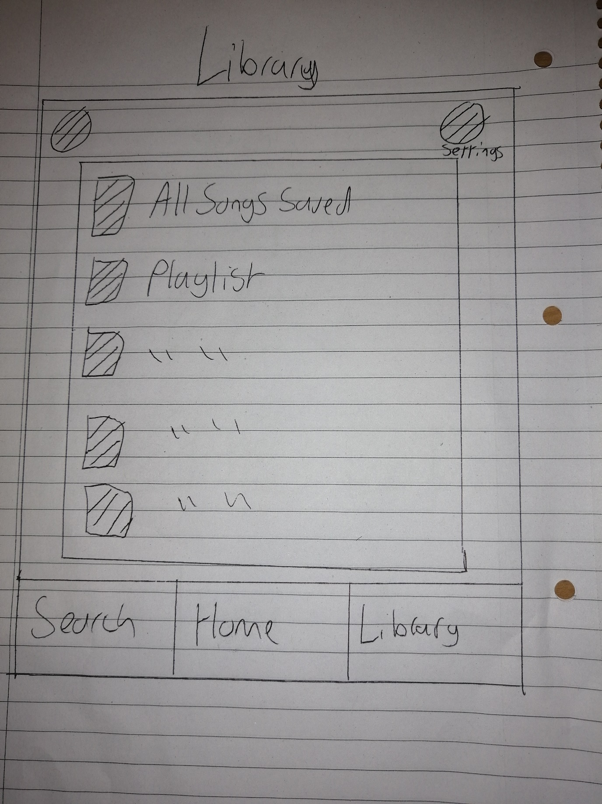

PR1.6

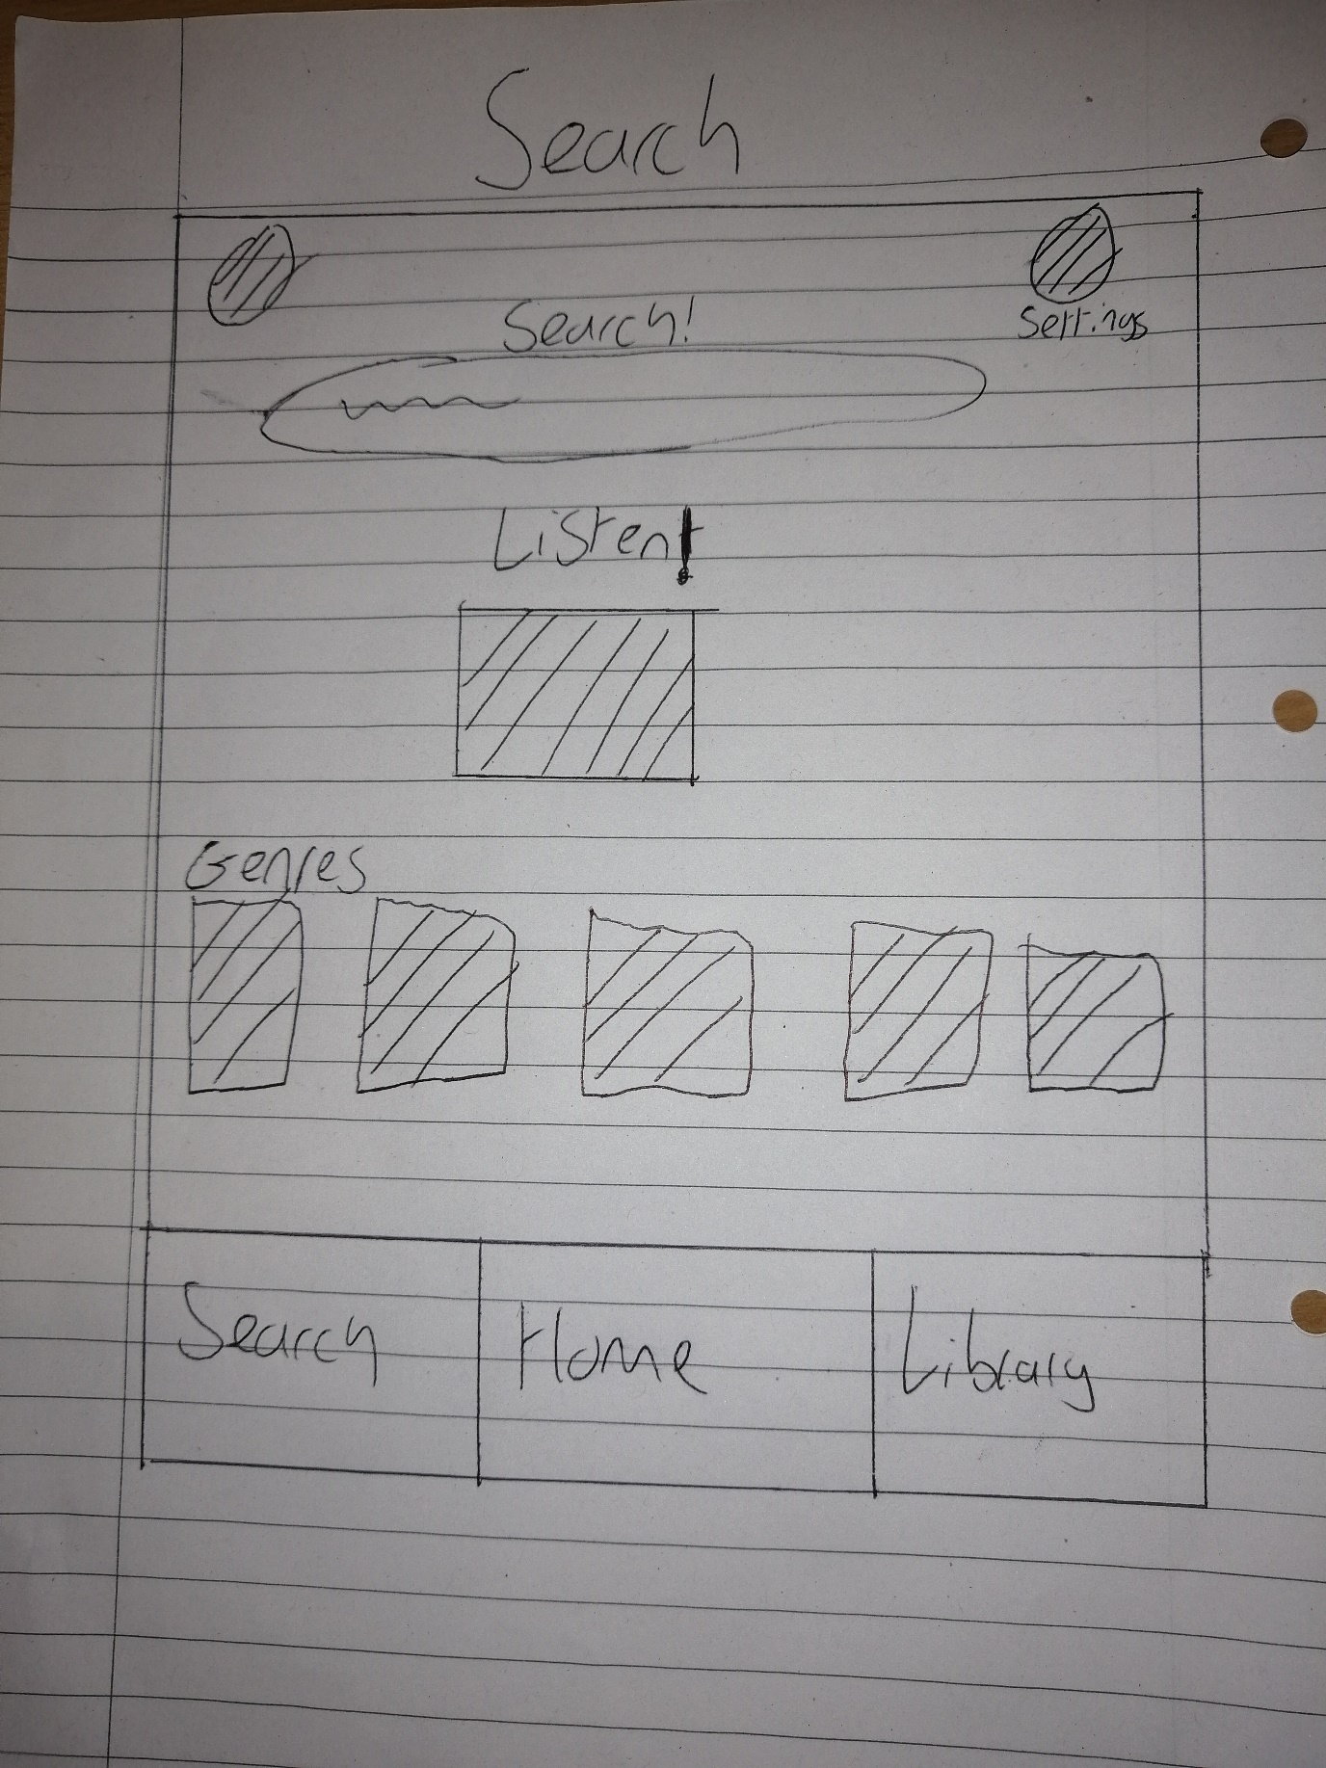

PR1.7

### Second Prototype

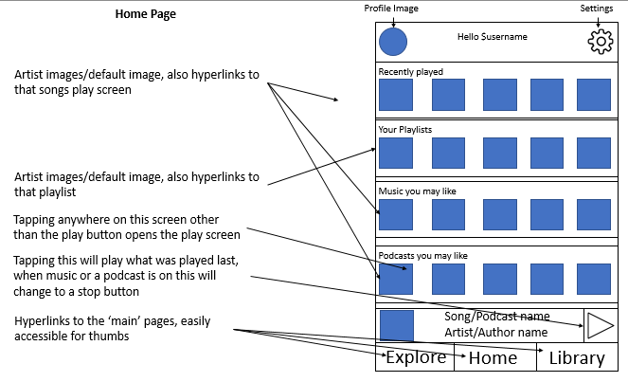

PR2.1

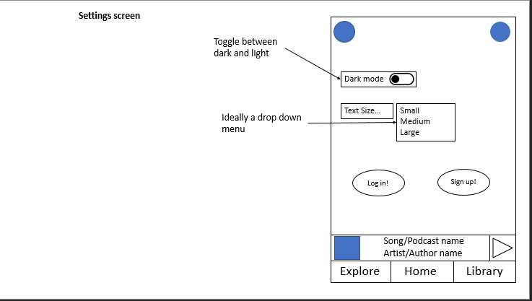

PR2.2

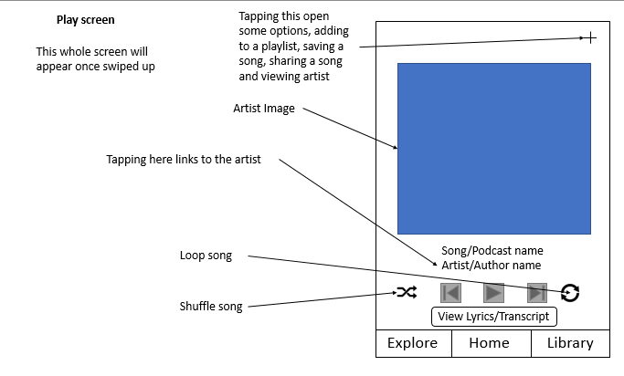

PR2.3

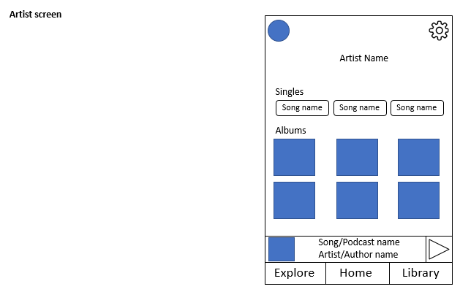

PR2.4

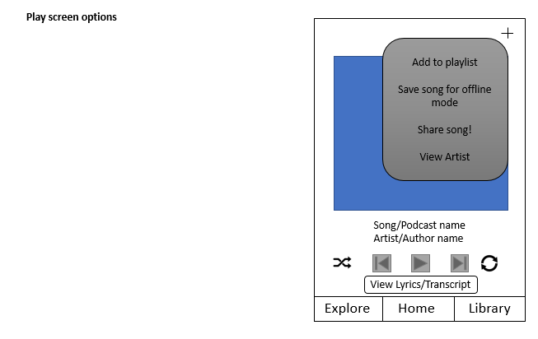

PR2.5

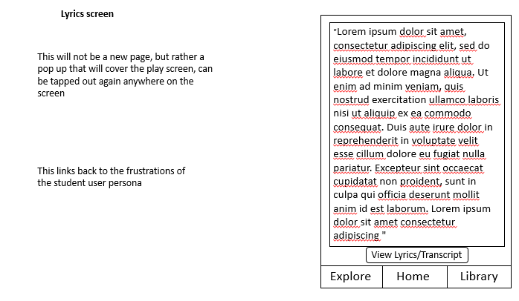

PR2.6

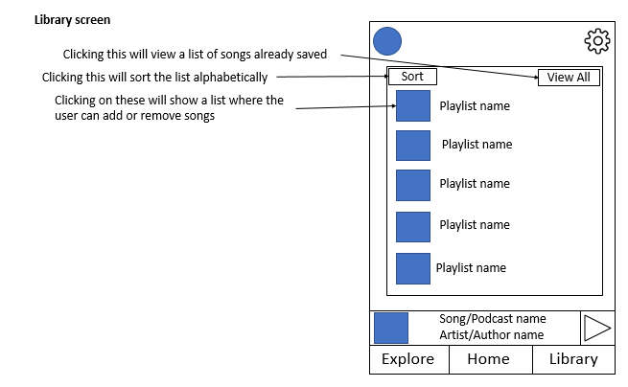

PR2.7

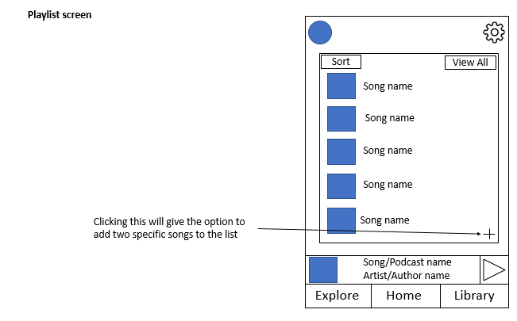

PR2.8

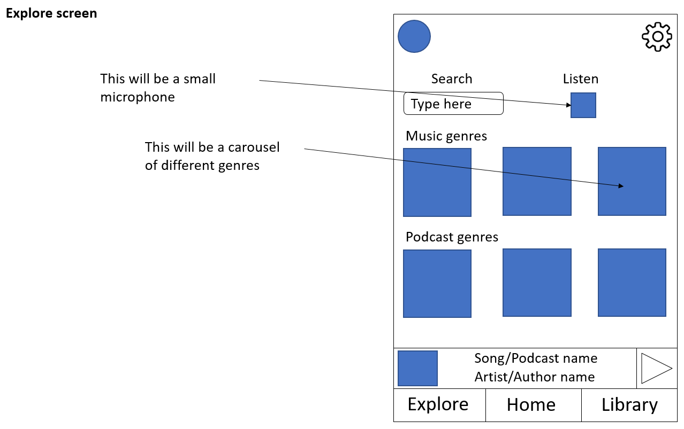

PR2.9

## Conducting heuristic evaluations

The heuristic that will be tested against will be Nielsen’s 10 heuristics.

They are:

1. Visibility of system status
2. Match between system and the real world
3. User control and freedom
4. Consistency and standards
5. Error prevention
6. Recognition rather than recall
7. Flexibility and efficiency of use
8. Aesthetic and minimalist design
9. Help users recognize, diagnose, and recover from errors
10. Help and documentation

|  |
| --- |
| The evaluator also assesses the severity of each usability problem, based on four factors: how common is the problem, how easy is it for the user to overcome, will it be a one-off problem or a persistent one, and how seriously will the problem be perceived? These can be combined into an overall severity rating on a scale of 0– 4:  0 = I don’t agree that this is a usability problem at all  1 = Cosmetic problem only: need not be fixed unless extra time is available on project  2 = Minor usability problem: fixing this should be given low priority  3 = Major usability problem: important to fix, so should be given high priority  4 = Usability catastrophe: imperative to fix this before product can be released  Source: Dix, Alan, et al. Human-Computer Interaction, Pearson Education UK, 2003. ProQuest Ebook Central, http://ebookcentral.proquest.com/lib/mmu/detail.action?docID=5136419. |

|  |  |  |  |  |
| --- | --- | --- | --- | --- |
| Heuristic Index | Heuristic Violated | Problem Description | Severity | Solution |
| 1 | Aesthetic and minimalist design | The home page seems too busy and has too many buttons to press | 3 | The solution for this issue will be to have less album/playlists and to have them bigger |
| 2 | Consistency and standards | To log on the user was unsure whether to press on the profile image or the settings logo, they complained that the profile image would be too much of a stretch for their thumb | 3 | Remove profile image from top left of the screen and move it to the settings. Also to create a landing page from where a user can log on before they hit the home page |
| 3 | Aesthetic and minimalist design | While on the lyrics screen, the user complained that there were too many words on the screen at once and would instead like the words to appear one sentence at a time as they are being sung | 0 | The reason this isn’t an issue as this allows the user to read all the lyrics even when the music isn’t playing |
| 4 | Visibility of system status | The user was unaware as to what text size they were currently in the settings screen | 1 | A line could be added above this telling the user what their size currently is |
| 5 | Consistency and standards | Log in and sign up is odd in settings | 2 | These styles of buttons aren’t seen anywhere else in the app, the solution mixes in with the redesign of the settings screen to include a profile page with a logout option and the creation of a new landing/login and sign up page |
| 6 | User control and freedom | No music progress slider, user can’t skip to a certain point in a song on the play screen | 3 | This is agreed that this is an issue and will be updated to include a progress slider |
| 7 | User control and freedom, Match between system and the real world | No volume control on the screen or in the app itself | 0 | As most devices have their own volume control on the side of the phones this app will rely on that |
| 8 | Consistency and standards | Single name and album art are not the same on the Artist screen. | 1 | The solution for this is simple, to either have them all as album/single art or to have them all as words in a list |
| 9 | Flexibility and efficiency of use | In the artist screen the only way to see the albums is through image, this is an accessibility issue | 2 | Add the names of albums under the art |
| 10 | Consistency and standards | Library screen doesn’t need a view all button. Redundant feature | 3 | This is correct, a solution would be to remove this and have all the playlist on one page with the ability to scroll down |
| 11 | Consistency and standards | Plus button on the playlist screen isn’t in the same place as it is on the play screen | 1 | The button on the playlist screen can change to the same place as the play screen |

## Final Designs

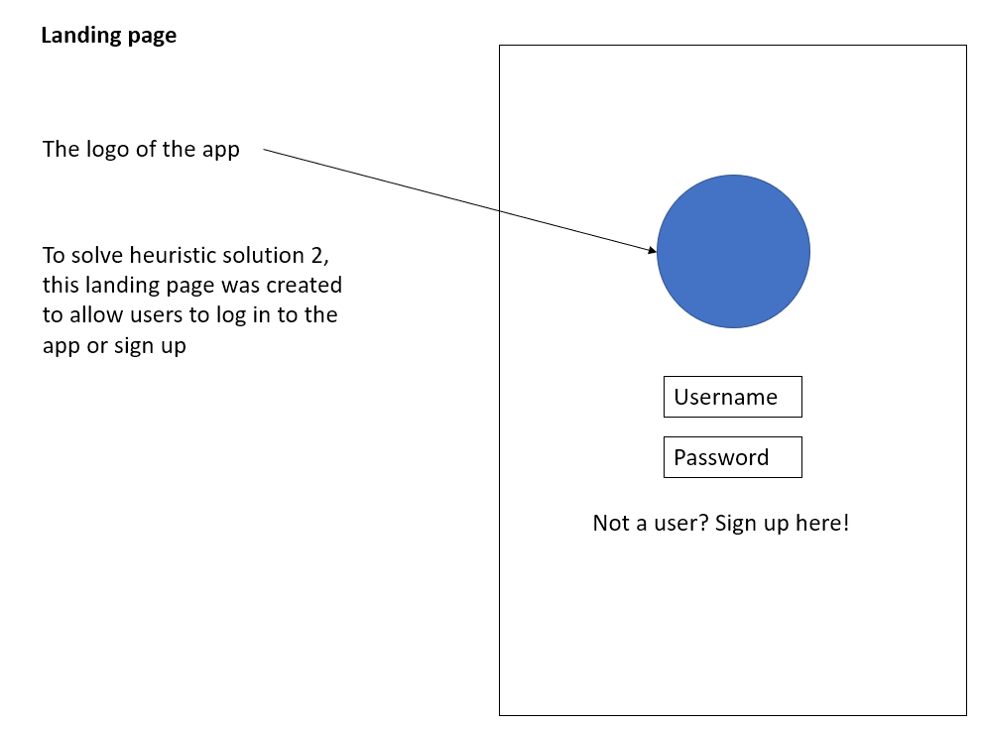

RD1

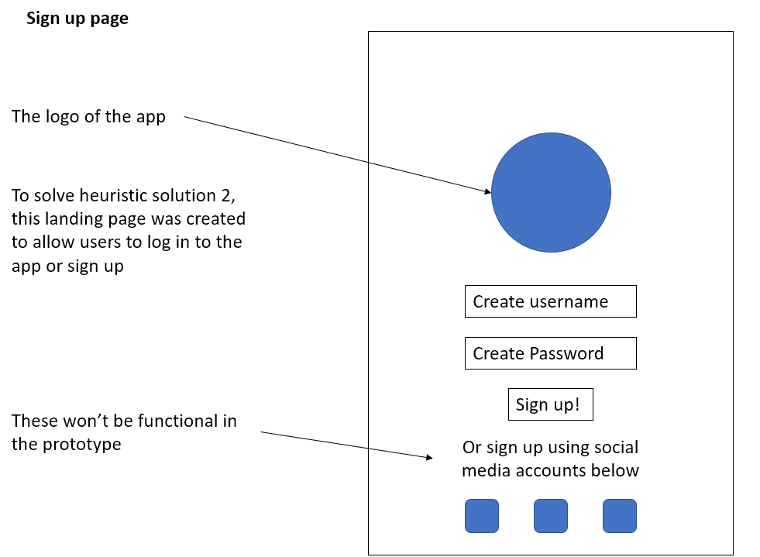

RD2

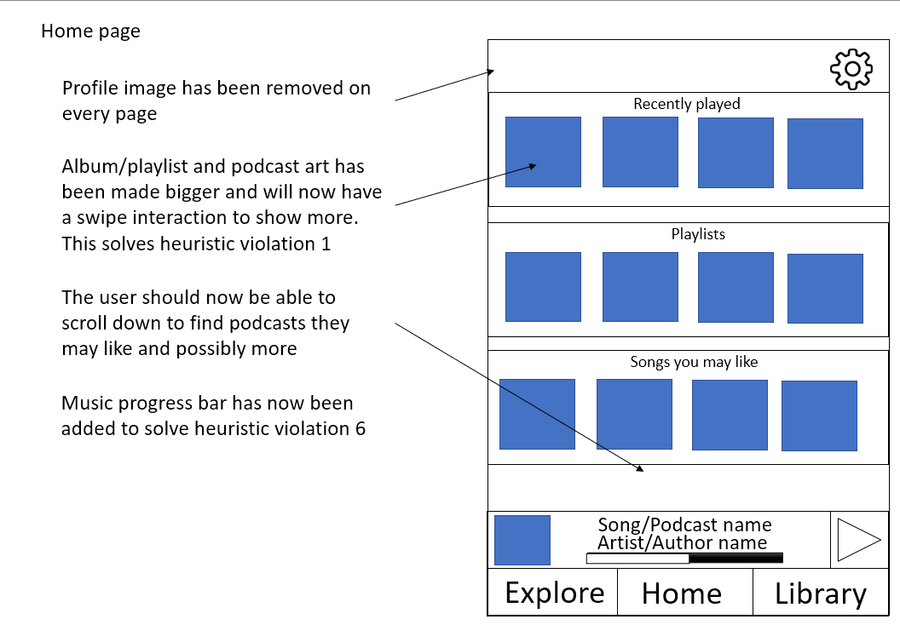

RD3

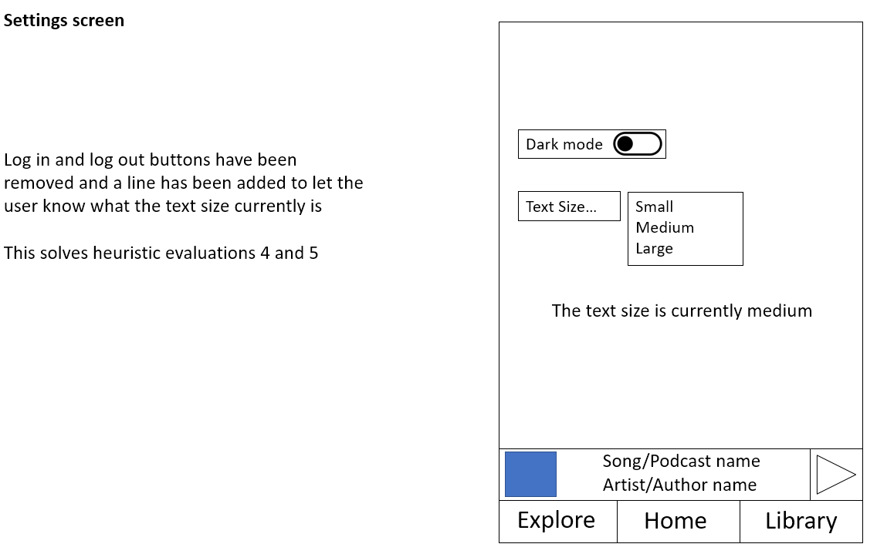

RD4

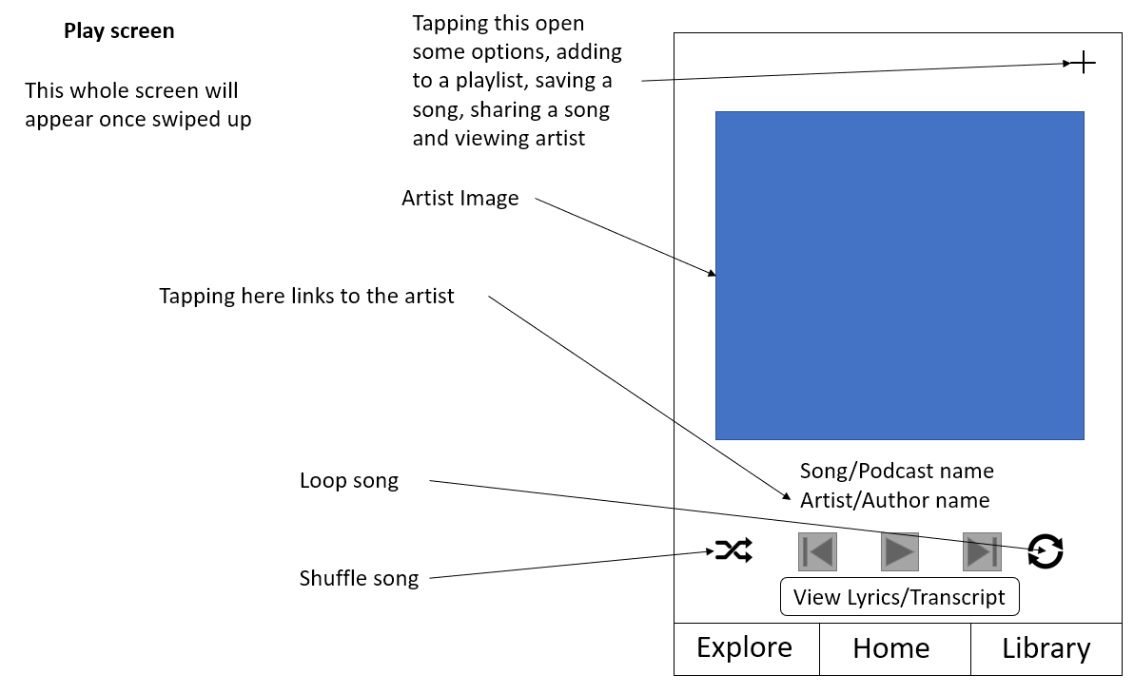

RD5

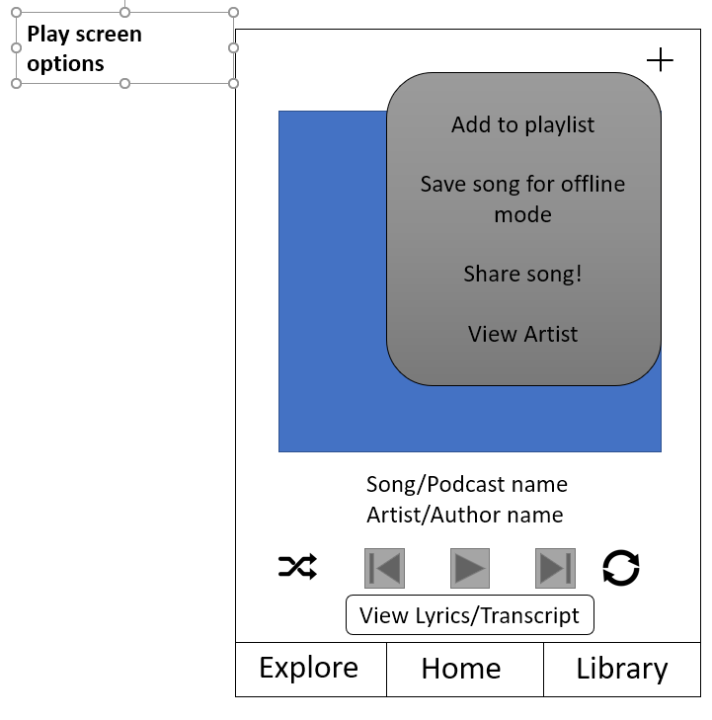

RD6

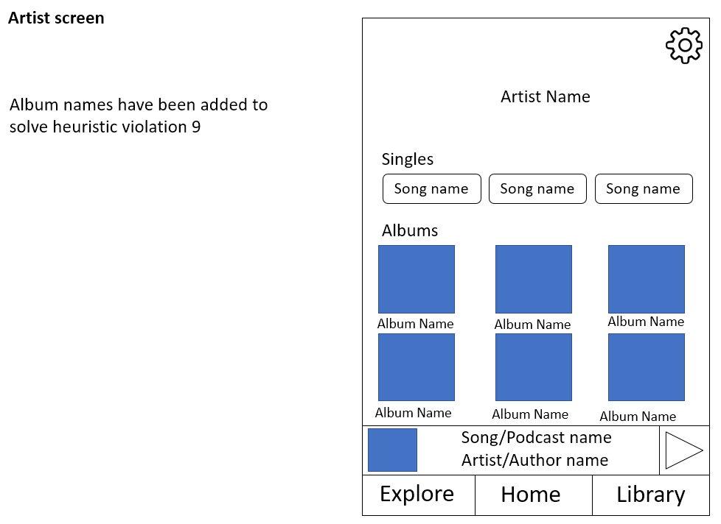

RD7

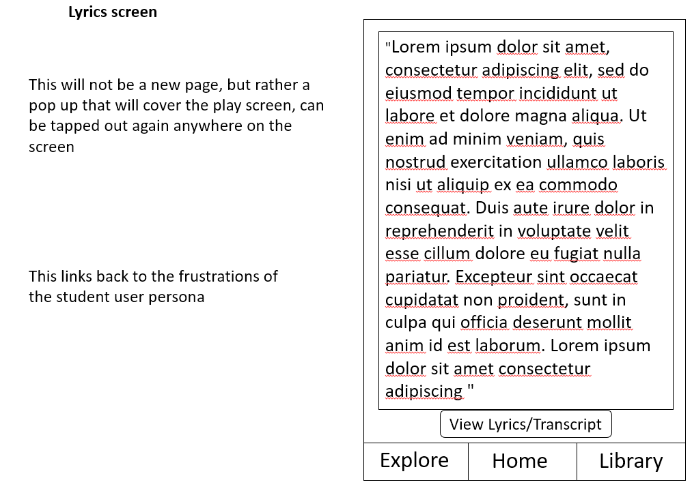

RD8

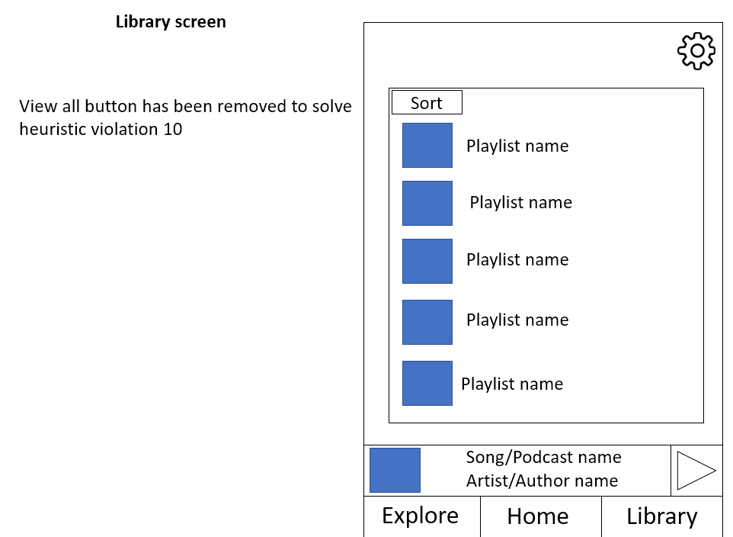

RD9

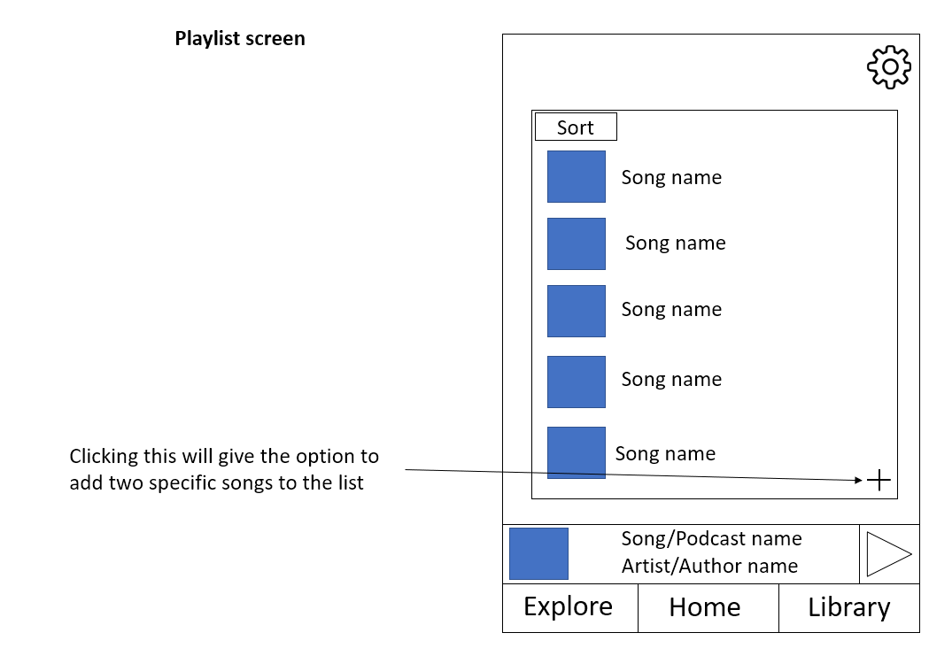

RD10

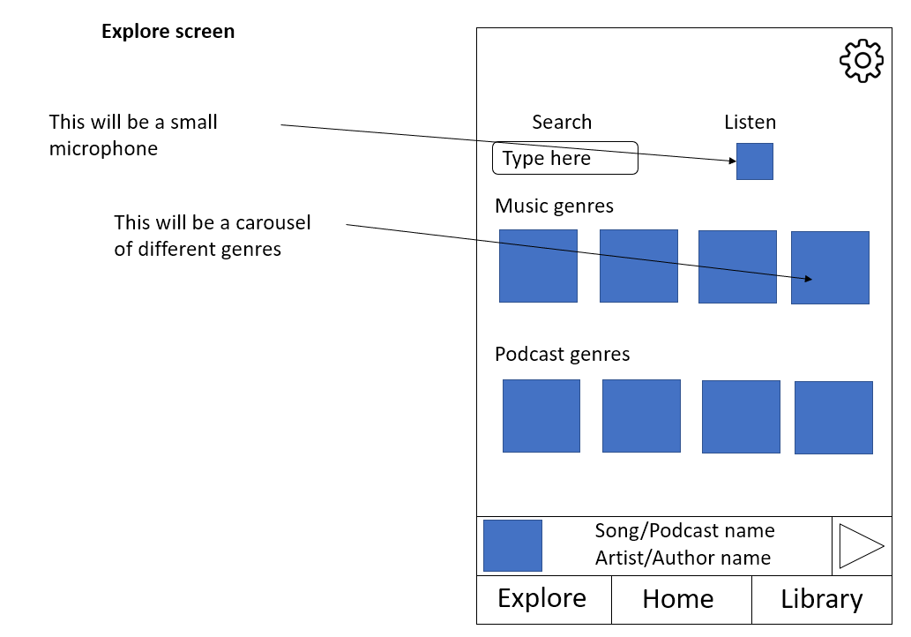

RD11

## Shortlisting and Analysing competitor apps

* How long should you interact with apps before scoring them?
  + 2/3 minutes
* Can you give your interactions some structure using a specific set of tasks (e.g., those developed during the virtual user testing exercise above)?
  + Create a playlist
  + Play a song (10 seconds)
  + Skip a song
  + Add a song to playlist
  + Search for a song

### Spotify

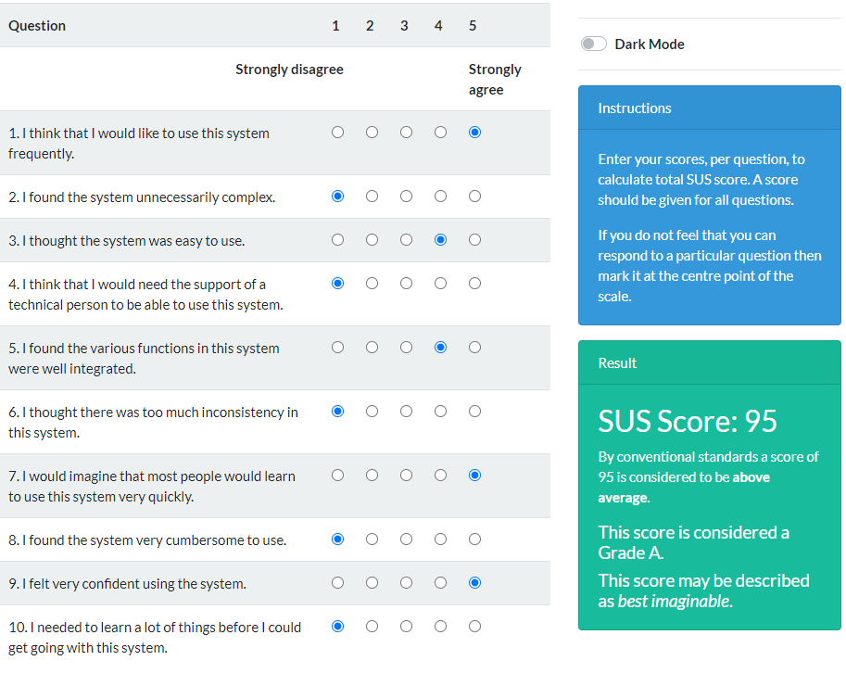

### Amazon Music

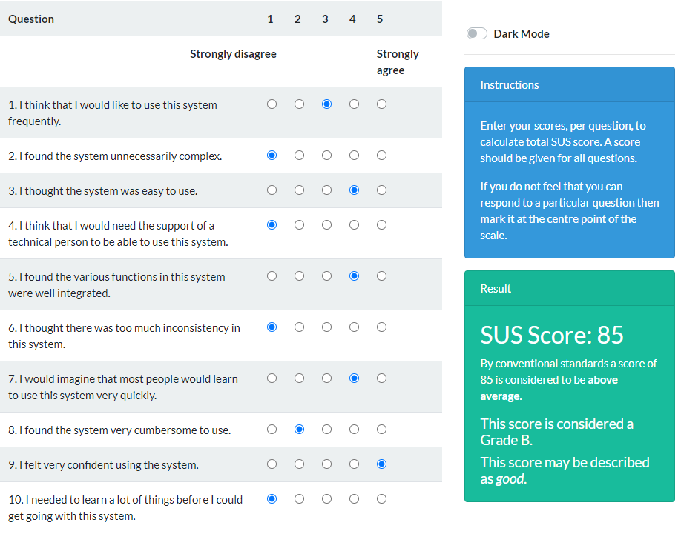

### Deezer

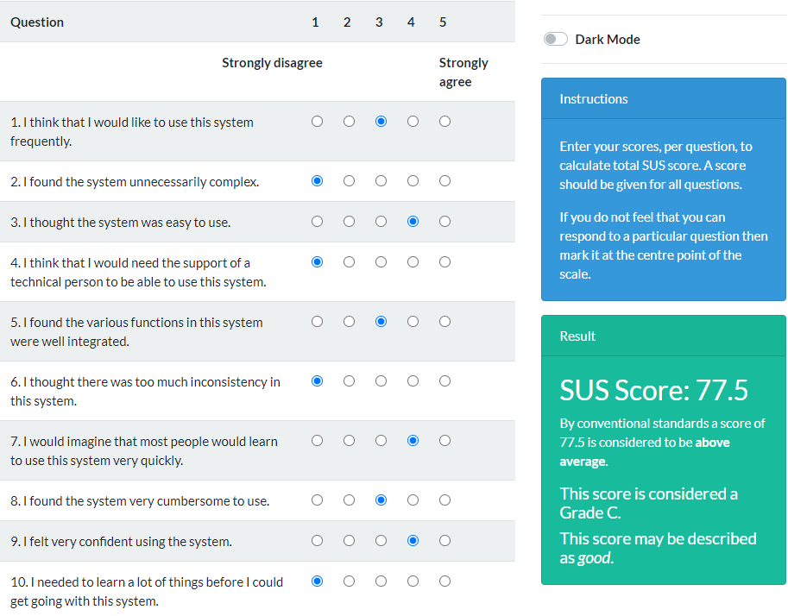

### YT Music

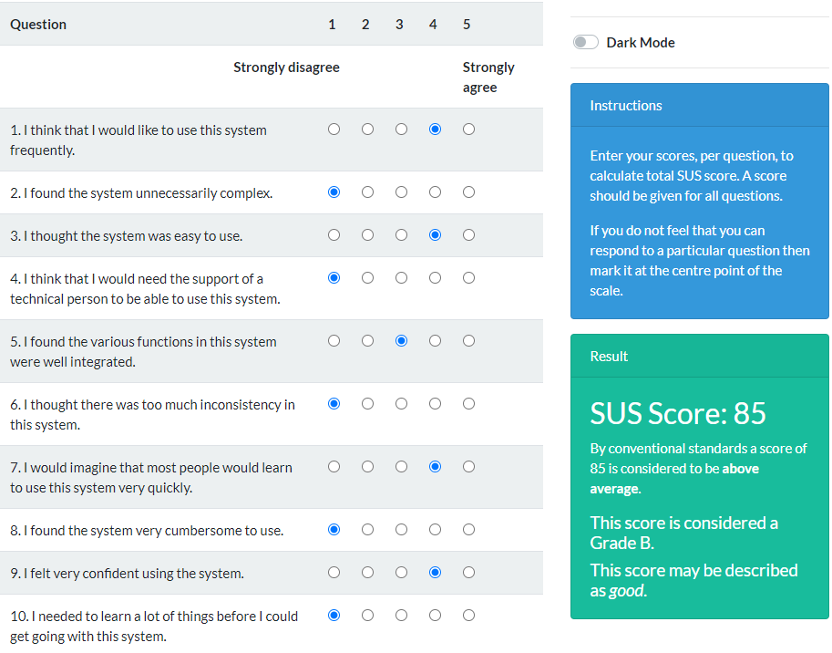

### Tidal

Wouldn’t let me play any song without a paid membership. But I could create and add to a playlist so I’m basing my score on that

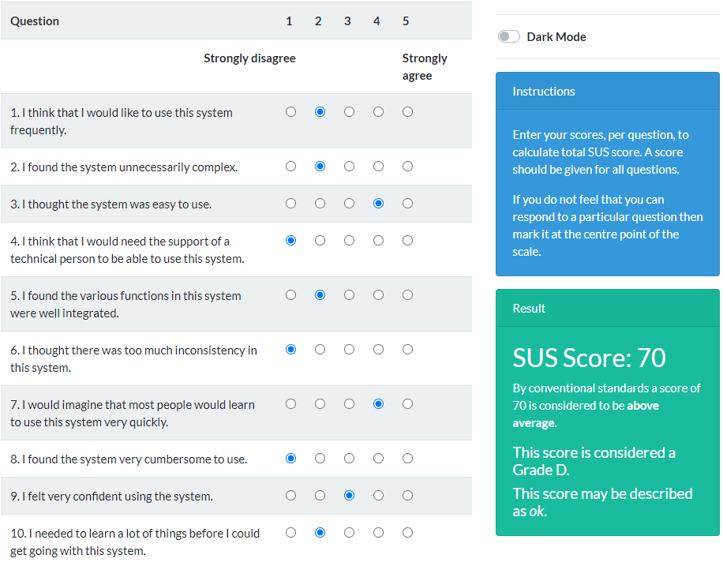

### Graph of SUS scores

## Analysing competitor apps

To continue with the theme of using Nielsen’s 10 heuristics these will be used for this competitor analysis.

They are:

1. Visibility of system status
2. Match between system and the real world
3. User control and freedom
4. Consistency and standards
5. Error prevention
6. Recognition rather than recall
7. Flexibility and efficiency of use
8. Aesthetic and minimalist design
9. Help users recognize, diagnose, and recover from errors
10. Help and documentation

|  |
| --- |
| The evaluator also assesses the severity of each usability problem, based on four factors: how common is the problem, how easy is it for the user to overcome, will it be a one-off problem or a persistent one, and how seriously will the problem be perceived? These can be combined into an overall severity rating on a scale of 0– 4:  0 = I don’t agree that this is a usability problem at all  1 = Cosmetic problem only: need not be fixed unless extra time is available on project  2 = Minor usability problem: fixing this should be given low priority  3 = Major usability problem: important to fix, so should be given high priority  4 = Usability catastrophe: imperative to fix this before product can be released  Source: Dix, Alan, et al. Human-Computer Interaction, Pearson Education UK, 2003. ProQuest Ebook Central, http://ebookcentral.proquest.com/lib/mmu/detail.action?docID=5136419. |

### Heuristic evaluation Spotify

|  |  |  |  |  |
| --- | --- | --- | --- | --- |
| Heuristic Index | Heuristic Violated | Problem Description | Severity | Solution |
| SPV1 | Aesthetic and minimalist design | Too many options on the home screen, the user typically knows what they wanted to listen to and so went to the library or the search menu. The user scrolled down a little and got bored before it reached the end | 2 | A solution could be to have a separate explore page for those users who wish to explore the apps algorithm. Then have the home page as something quite minimal and more aesthetically pleasing |
| SPV2 | Consistency and standards | Comparing the home page where you can swipe the recently played and other genres to the search page where you cannot swipe your top genres | 1 | Since the majority of the app allows for swipe actions the easiest solution would allow the user to swipe more than two genres |
| SPV3 | Consistency and standards | The settings icon in the home and the library pages are different, on the home page it’s the traditional gear/cog symbol and on the library page you can access it when you press on the profile image | 1 | Make the settings image the same |
|  |  |  |  |  |

|  |  |  |  |
| --- | --- | --- | --- |
| Heuristic Index | Heuristic | What it does well? | Screenshot (if any) |
| SPG1 | Visibility of system status | Spotify uses its logo as a loading page while the app opens. You are aware when it has worked as you will be on the home page |  |
| SPG2 | Match between system and the real world | On the search page, Spotify uses real world phrases like ‘Workout’, ‘Party’ and ‘Sleep’ to describe music genres that can be listened to depending on the activity you’re doing or the type of mood you’re in |  |
| SPG3 | User control and freedom | Users can very quickly go between the play screen and any other screen they’re on |  |
| SPG4 | Consistency and standards | Spotify has done an excellent job of using well known icons and buttons, so the users know what things mean, good examples are using a bell for a notification or a heart to show that you’ve liked a song |  |
| SPG5 | Error prevention | When a user has no internet, a small pop up appears telling the user that, Spotify also shows what songs are available due to what’s been downloaded and have greyed out the songs that cannot be played |  |
| SPG6 | Recognition rather than recall | Spotify will show you a bands logo or an artist’s face which allows the user to instantly recognise who they are. |  |
| SPG7 | Flexibility and efficiency of use | On the play screen Spotify has the ability to swipe left and right to change songs or the buttons the skip and back button either side of the play button |  |
| SPG8 | Aesthetic and minimalist design | Spotify uses the theme of big images with smaller words to show an explanation of what the image is, this is used throughout the app |  |

### Heuristic evaluation Amazon

|  |  |  |  |  |
| --- | --- | --- | --- | --- |
| Heuristic Index | Heuristic Violated | Problem Description | Severity | Solution |
| AMV1 | Aesthetic and minimalist design | The same as Spotify being that there are too many options on the home screen, the user typically knows what they wanted to listen to and so went to the library or the search menu. The user scrolled down a little and got bored before it reached the end | 2 | A solution could be to have a separate explore page for those users who wish to explore the apps algorithm. Then have the home page as something quite minimal and more aesthetically pleasing |
| AMV2 | Help and documentation | Although it is there, Amazon has made it difficult to find the support button with it being at the very bottom of the settings page after a long scroll | 1 | Allow users to search in the settings |

|  |  |  |  |
| --- | --- | --- | --- |
| Heuristic Index | Heuristic | What it does well? | Screenshot (if any) |
| AMG1 | Visibility of system status | Amazon music uses its logo as a loading screen while the app opens. You are aware when it has worked as you will be on the home page |  |
| AMG2 | Match between system and the real world | Amazon uses icons such as a magnifying glass and headphones to link to the real world in their menu, magnifying glass falls under find and the headphones mean library |  |
| AMG3 | User control and freedom | If a user accidentally presses on a paid feature, they are given the option to exit |  |
| AMG4 | Consistency and standards | Amazon has used well known icons in the design world like a notification bell or a settings cog |  |
| AMG5 | Error prevention | Amazon has a popup that tells you when you’ve put the same song in a playlist |  |
| AMG6 | Recognition rather than recall | Amazon uses the widely known options icon which opens up to extra options for a song or a playlist |  |
| AMG7 | Flexibility and efficiency of use | Amazon allows the use of Alexa voice commands to play or control music in the options, perfect for experienced users |  |
| AMG8 | Aesthetic and minimalist design | Amazons home page is not cluttered with words and information but rather has minimalistic words under images, making this easy to read and understand what’s going on |  |

# Component Two

## Tasks

Tasks for Sign up page

1. Input incorrect email address then press submit
2. Input correct email address and incorrect password
3. Input correct email and password and proceed to log in page

Tasks for log in page

1. Input incorrect email address then press submit
2. Input correct email address and incorrect password
3. Input correct email and password and log in

Tasks for Home Page

1. Swipe left on recently played once
2. Swipe right on recently played once
3. Swipe left on your playlists once
4. Swipe right on your playlists once
5. Swipe left on artists you may like once
6. Swipe right on artists you may like once
7. Press the play button
8. Press the stop button
9. Press anywhere to the left of the play button

Tasks for Play Screen

1. Swipe up on the lyrics for lyrics
2. Swipe back down
3. Skip forward one song
4. Skip back one song
5. Press the loop button
6. Skip forward twice
7. Press the loop button again to switch off
8. Press the shuffle button
9. Skip forward one song
10. Skip back one song
11. Press shuffle button again to turn off
12. Press the plus button
13. Press save song
14. Press view artist

Tasks for Artist screen

1. Swipe left on singles
2. Swipe left on albums
3. Press the explore button

Tasks for Explore page

1. Swipe left on music genres
2. Swipe left on podcast genres
3. Press the microphone
4. Search for the phrase ‘The’
5. Search the letter ‘A’
6. Press the Library button

Tasks for Library page

1. Press the plus icon
2. Press create playlist
3. Name this A Playlist
4. Press create
5. Press sort
6. Press the new playlist

Tasks for new playlist page

1. Press the plus button
2. Press add songs
3. Type in ‘song’
4. Type ‘song 2’
5. Press finish
6. Press the settings icon in the top right

Tasks for settings page

1. Toggle light mode
2. Change font size to small
3. Toggle dark mode
4. Change font size to large
5. Toggle light mode
6. Log out

## Plan for deployment

* **Participants** – who would you want to recruit to participate and what exactly would you ask your participants to do
  + I would recruit 5 people who closely relate the personas I have created, I would only choose 5 due to the research that 5 users typically find 85% of usability errors (Martin, 2016)
  + The users will be testing the Axure prototype and would be given a list of tasks to complete. They would be expected to explain why they are doing what they are doing for each task, this session would be recorded, and the users would be observed throughout.
* **Environment** – where would you want the user testing to take place and any aspects of the environment you would want to control
  + The users would be testing the prototype in a controlled environment like a usability lab. They would be completing these tasks alone without interference from the UI/UX team, this is so the team can get the most useful information from the user. (ALLABARTON, 2022)
* **Data** – what data would you want to collect before/during/after each person’s interactions with the prototype and how you would do this
  + The data that would be collected from this is how a user interacts with the prototype and how they get to different parts of the prototype. It’s about mapping a user’s journey while taking notes on how and why the user did what they did, other useful data would be finding out any errors the users may run into and what would make. The user will also be asked to fill out a interview asking about the useability and ease of the prototype

# Component Three

## Future development plan

### Sonic Interaction

There are two main approaches to Sonic Interaction, these being earcons and auditory icons. The simplest differentiation between the two are that earcons have a musical element to them while auditory icons do not require this. There is also speech output and recognition systems such as Siri and Cortana.

Some pros and cons for sonic interaction within an app are:

* Pros
  + Helps visually impaired people
  + Sound grabs attention
  + Reduces demand on visual attention
* Cons
  + Sounds may be misinterpreted
  + Sounds may not be universally understood or even outdated
  + Sounds may be annoying

In the prototype, I have elected to deploy earcons. This is because I believe they have clearer intentions and may not be outdated or misinterpreted. Below are a couple of ways in which I will be implementing the earcons.

The needs of the users who may be visually impaired have been considered while designing these sounds, while a typical user will be able to see the volume control pop up on screen or see the microphone pop up that says it’s listening, a visually impaired user may have trouble doing so. These sounds will ensure that these users needs are being met.

|  |  |
| --- | --- |
| **App Feature** | **Earcon** |
| Volume control | One singular beep in a higher pitch and in a lower pitch to show the sound getting higher or lower  <https://musiclab.chromeexperiments.com/Song-Maker/song/5741442911174656>  The above link represents the sound that the volume going higher noise will be  <https://musiclab.chromeexperiments.com/Song-Maker/song/4538862335950848>  The above link will show what the volume getting lower noise will sound like |
| Microphone listening | This will be a one note rhythm which plays on a tempo of 100, this will last as long as the app is listening for a song  <https://musiclab.chromeexperiments.com/Song-Maker/song/6650567228653568> |

### Affective design

It is my intention to employ different classes of emotions. In relation to my app I intend to organise the music options into genres relating to different moods. This will be communicated via the user directly and will require their input in terms of declaring what genre would suit them currently. The model that best suits my affective interaction design would be a dimensional model of emotion, such as Russell’s circumplex model (1980) This would be best suited since it shows a wide range of emotions that fit in effectively with many types of music. Technologies that could be used in a future version of the Ultimate Music Streaming App could be facial technology in which a user would present their face to a camera and have the app pick up on their particular mood and put forth songs based on the mood it reads.

|  |  |
| --- | --- |
| **Affective Features** | **The Ultimate Music Streaming App** |
| Technologies that recognise emotions | If the user inputs a mood into the app, then songs could be generated to affect that mood. For example, the user says that they are in a bad mood, a playlist could be created which starts of slow and sad but gradually builds up towards happier songs. Helping a user to overcome their sadness |
| Technologies that express emotions | When a user saves a song, a love heart pops up on the screen giving the connotation that the user did something good |
| Technologies that have emotions | When a song is removed from a user’s favourites, a pop up could appear first with the phrase ‘Are you sure? ☹” with a sad face, expressing that the app is sad that this song is being removed from favourites |

# Bibliography

ALLABARTON, R., 2022. *What Is the UX Design Process? A Complete, Actionable Guide.* [Online]   
Available at: https://careerfoundry.com/en/blog/ux-design/the-ux-design-process-an-actionable-guide-to-your-first-job-in-ux/#:~:text=The%20UX%20design%20process%20can,UX%20is%20an%20iterative%20process.  
[Accessed 2022].

Ćalić, N., 2021. *Working From Home Statistics UK Edition 2021.* [Online]   
Available at: https://cybercrew.uk/blog/working-from-home-statistics-uk/

Hlebowitsh, N., 2021. *Spotify Statistics & Facts – A Quick Snapshot:.* [Online]   
Available at: https://siteefy.com/spotify-statistics/#:~:text=Statistics%20for%20Spotify%20User%20Demographics,-On%20the%20whole&text=Spotify%20is%20also%20popular%20with,male%20and%2044%25%20are%20female.

Martin, E., 2016. *Why 5 is the magic number for UX usability testing.* [Online]   
Available at: https://www.invisionapp.com/inside-design/ux-usability-research-testing/  
[Accessed 2022].